**Bachelor Point**

This Is a meal management application. You can manage your meal system very easily.

There are 5 pages in this app. They are User, Meal, Bazar, Bill and Amount page. You can Access those pages by clicking User, Meal, Bazar, Bill and Amount button (On the left side of the app).

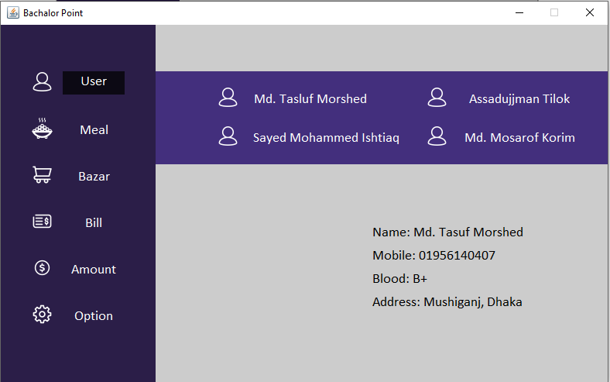

User Page:

You can find all the details about the users in User page. You can find Individual name, number, blood group and address info in there. Just click the **Names** and you can find the individual information in the down sections.

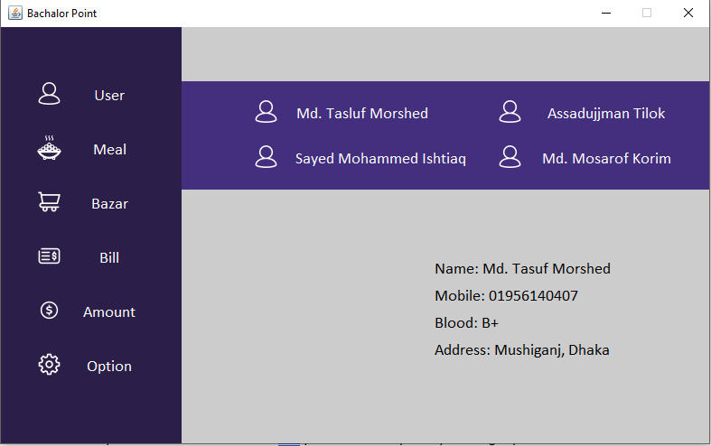

Meal Page:

In here you can add individual meal for every person. This info will show in the down table. By clicking **Submit** you can add this info into the table. Also you can delete any info by selecting any row of the table and then press **Delete**.

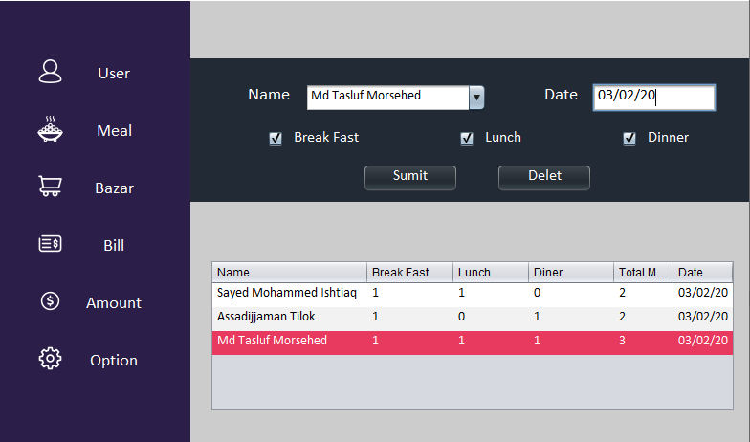

Bazar Page

You can add any Bazar information in here. You can add Item, amount and date into the table by Clicking the **Submit** button. Also, you can delete any info by selecting any row of the table and then press **Delete**.

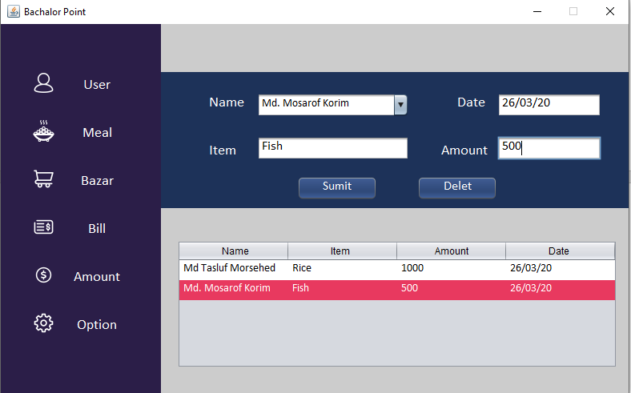

Bill Page

You can add any Bill information in here. You can add Bill, amount and date into the table by Clicking the **Submit** button. Also, you can delete any info by selecting any row of the table and then press **Delete**.

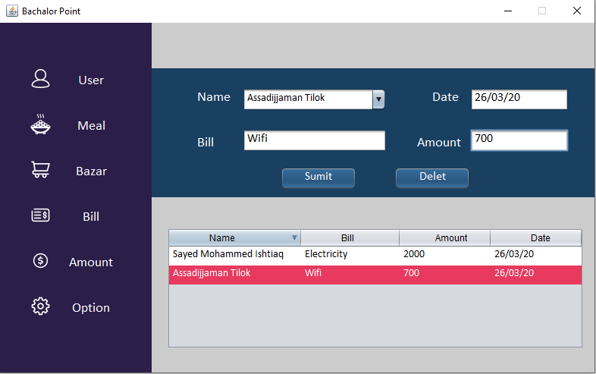

Amount Page

In here you can find Total Meal, Total Bill, Total Bazar, Individual Meal, Individual Spend

How much money you will receive and how much money you have to Pay. (It will automatically calculate the meal for individual so no need to calculate anything further).

You can find this information by click individual names in the upper section.

(**Click the Individual Names**)

